

root@cyberster:~$ whoami
> hanzallah — soc_intern
Day
67-73
Case File: Mantooth - Digital Forensics Investigation
// candidate Hanzallah
// program Cyberster — Cybersecurity Internship (Batch 2)
// tutor Abdullah Zia
[ STATUS: TASKS COMPLETE — READY FOR REVIEW ]
Days 67–69: Lab 1 Autopsy Triage & Artifact Hunting
Case: Mantooth Financial Fraud Investigation | Tool: Autopsy 4.21.0

$ Chain of Custody — Data Source Integrity
Evidence File: Mantooth.E01
Case Time Zone: Mountain Time (America/Denver) — set prior to Add Data Source
MD5 Hash (Data Source Integrity module):
Integrity Status: Verified — "Integrity of Mantooth.E01 verified" (Ingest Inbox, Data Source Integrity module)
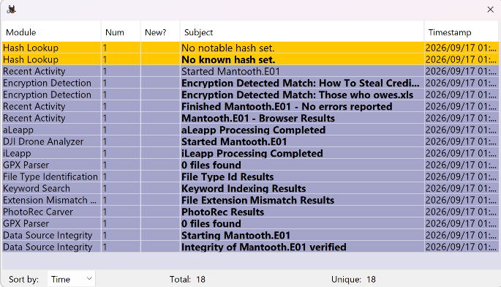
// 01 STEP 1 — CASE CREATION & IMAGE VERIFICATION

Q1. What is the MD5 hash of the Mantooth.E01 image as verified by Autopsy?
Artifact: Data Source Integrity module result
Path/Tool: Autopsy → Data Source Integrity ingest module
Finding: Data Source Verification Results for Mantooth.E01
- Result: verified
- MD5 hash verified
  - Calculated hash: 31217210a1a69f272079a3bde3d9d8fc
  - Stored hash: 31217210a1a69f272079a3bde3d9d8fc

Q2. How many partitions are on the evidence image? Include file system type, size, and offset for each.
Artifact: Volume/partition table
Path/Tool: Autopsy → Data Sources tree → Mantooth.E01 volumes

Volume | File System | Sector Range (Offset) | Notes
vol1 | Unallocated | 0 – 62 | —
vol2 | NTFS / exFAT (0x07) | 63 – 224909 | [CONFIRM — contains Windows install; verify via boot files]
vol3 | DOS FAT12 (0x01) | 224910 – 240974 | —
vol4 | Unallocated | 240975 – 250878 | —
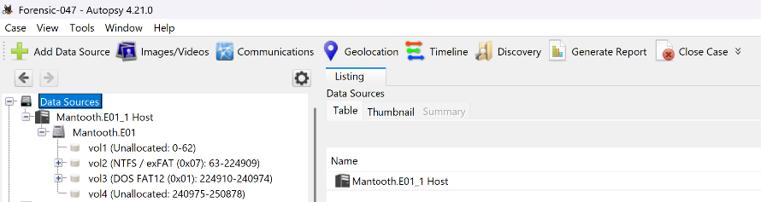
// 02 STEP 2 — TARGETED TRIAGE

Q3. Which photo was taken by an Olympus Optical device? Document filename, path, and identifying EXIF fields.
Artifact: EXIF Metadata
Path/Tool: Autopsy → Analysis Results → EXIF Metadata (8 hits)
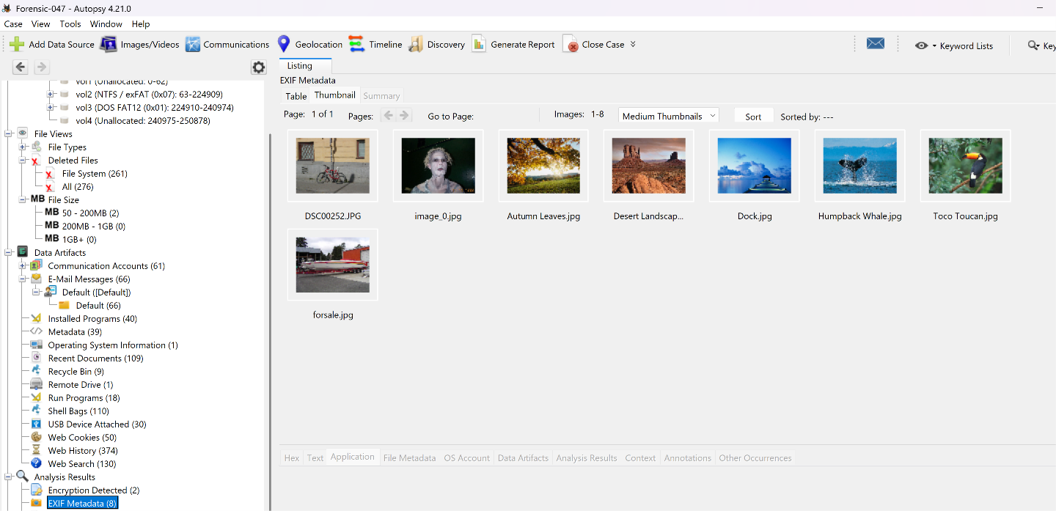
Q4. Which file is encrypted? Document filename, location, and indicators.
Artifact: Encryption Detected
Path/Tool: Autopsy → Analysis Results → Encryption Detected (2 hits)
Candidate Files: "How To Steal Credi[t...].???" and "Those who owes.xls" — [CONFIRM full filenames + paths in Encryption Detected panel]
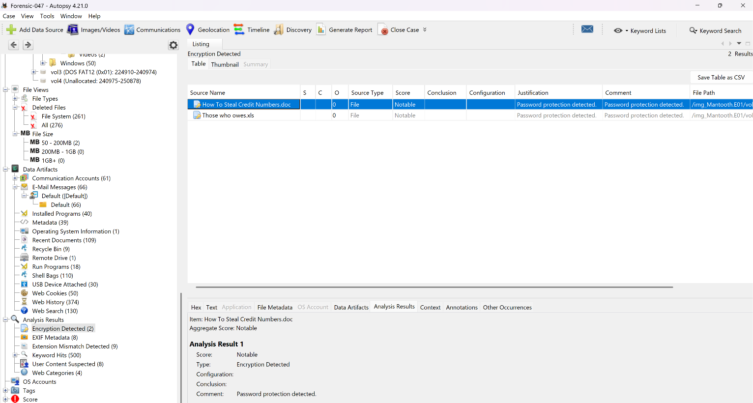
Q5. What happened to HARDCORE.jpg and pfah603.jpg? Deleted? Recoverable?
Artifact: Deleted Files
Path/Tool: Autopsy → File Views → Deleted Files, or direct filename search
HARDCORE.jpg — Status/Path: Active
pfah603.jpg — Status/Path: Active
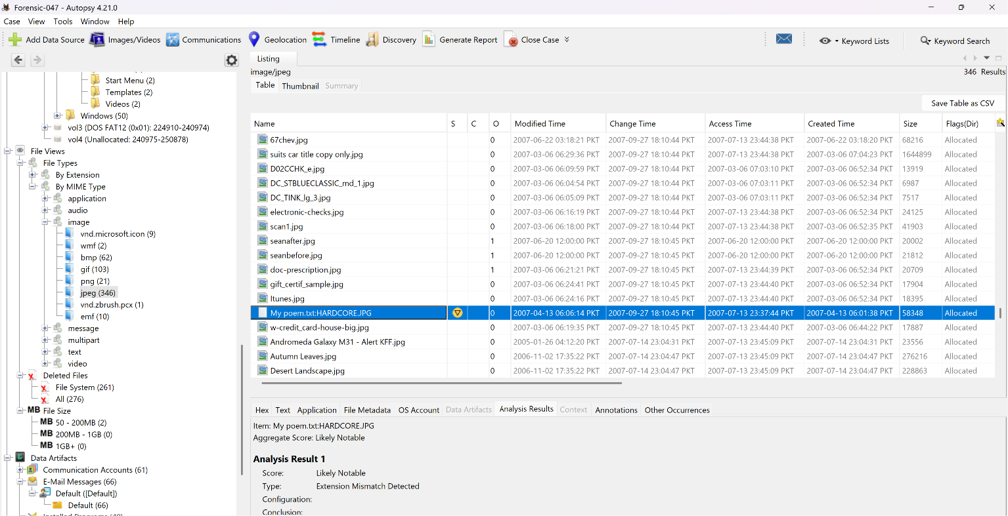
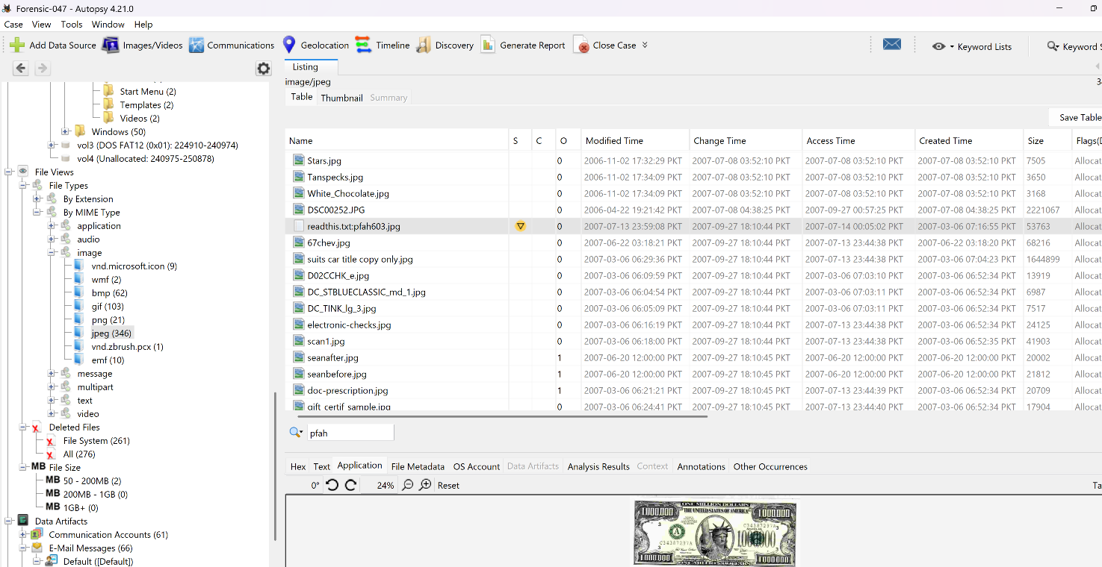
Q6. Review web search history — three main topics, terms, dates, and browser/engine.
Artifact: Web Search
Path/Tool: Autopsy → Data Artifacts → Web Search (130)
Topic 1: check washing
Topic 2: making meth
Topic 3: atm card stealing
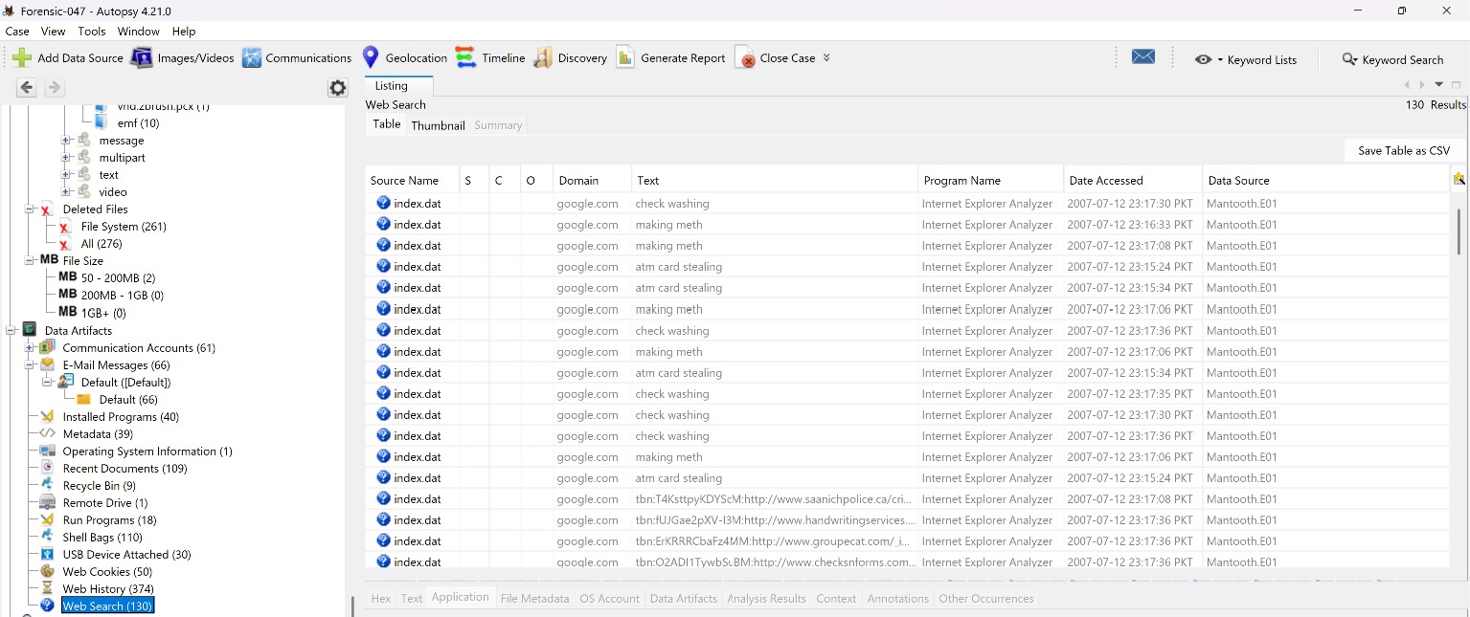

Q7. List three IP addresses and three email addresses, with context.
Artifact: Email Messages / Web History
Path/Tool: Autopsy → Data Artifacts → E-Mail Messages (66), Web History (374)
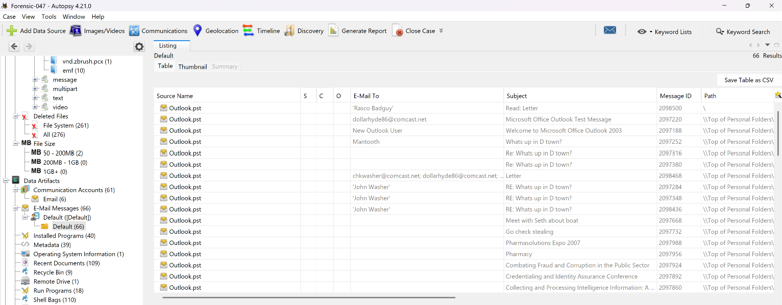

// 03 STEP 3 — WINDOWS ARTIFACT HUNTING
Q8. User accounts on the system, and ≥10 investigatively suspicious files in Wes Mantooth's directory.
Artifact: OS Accounts
Path/Tool: Autopsy → OS Accounts; Users\Wes Mantooth\
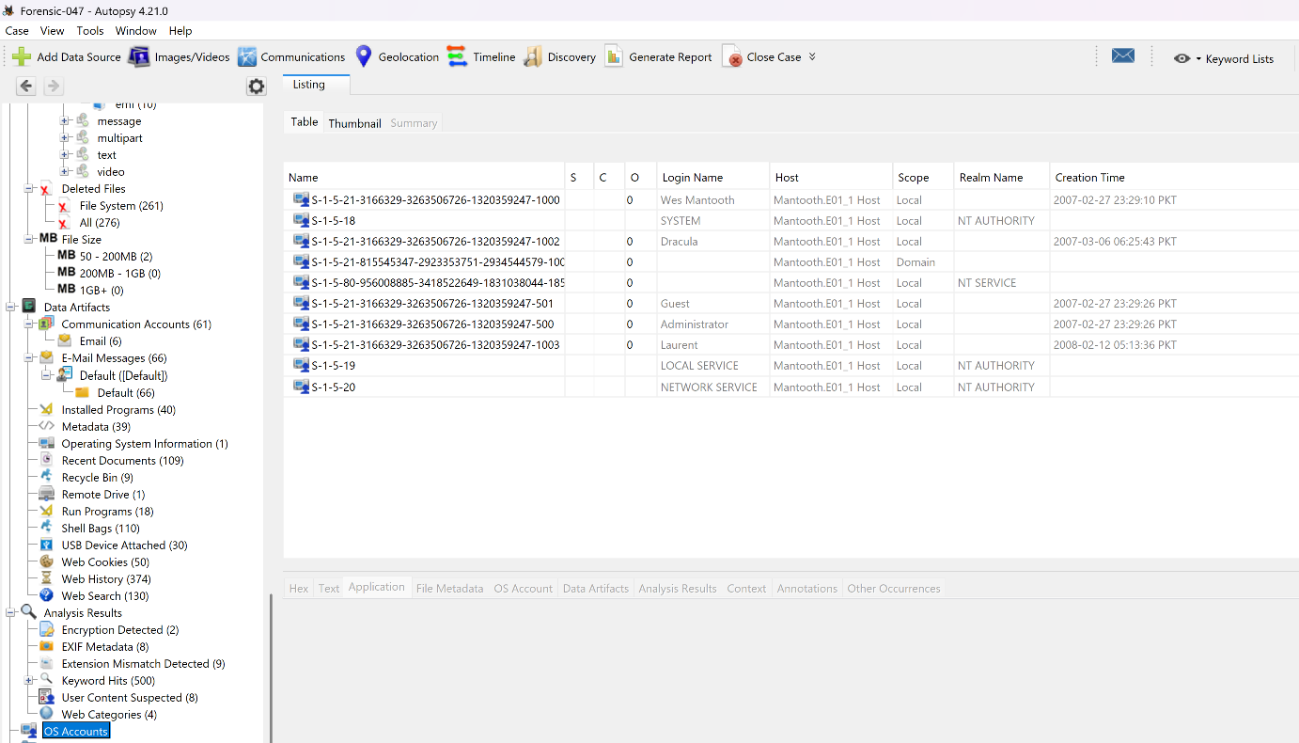
Q9. Thumbcache databases for Wes Mantooth — files, thumbnail count, significance.
Path/Tool: Users\Wes Mantooth\AppData\Local\Microsoft\Windows\Explorer\thumbcache_*.db
Databases Found: YES
Thumbnail Count: 6
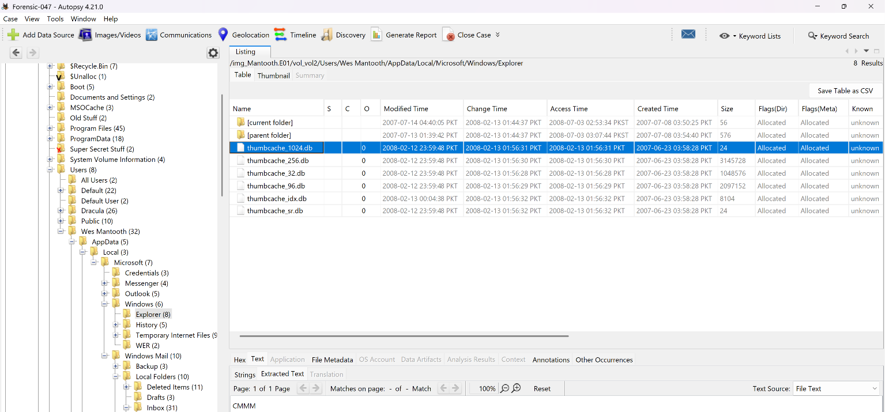
Q10. $I / $R pair for Camerashy.exe in Recycle Bin — original path, delete time, recoverability, and research findings.
Path/Tool: $Recycle.Bin\<SID>\ — Recycle Bin data artifact (9 entries)
Original Path: C:\Users\Wes Mantooth\Documents\CameraShy.exe
Deleted (Recycled) Time: 2007-07-14 22:55:57 PKT
Recoverable: YES
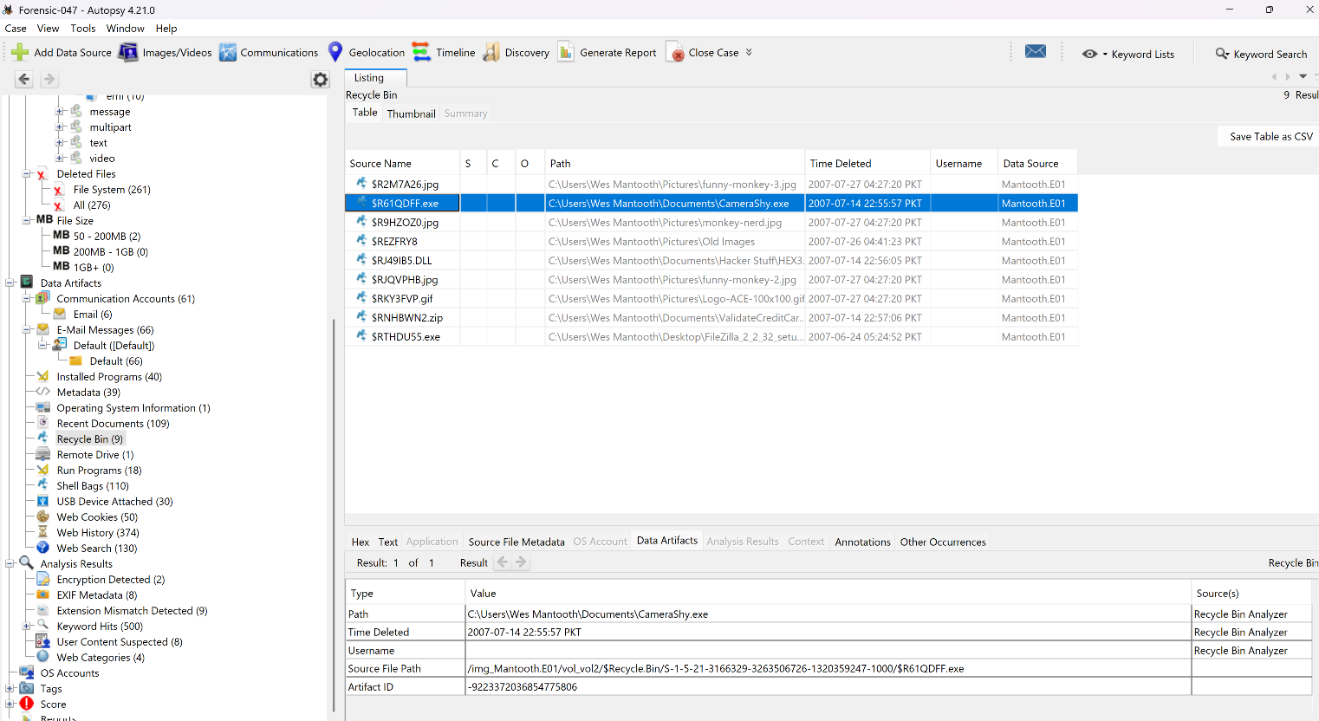
Q11. Prefetch entry for Xcopy — filename, embedded exe path, run count, last execution, significance.
Path/Tool: Windows\Prefetch\XCOPY.EXE-*.pf
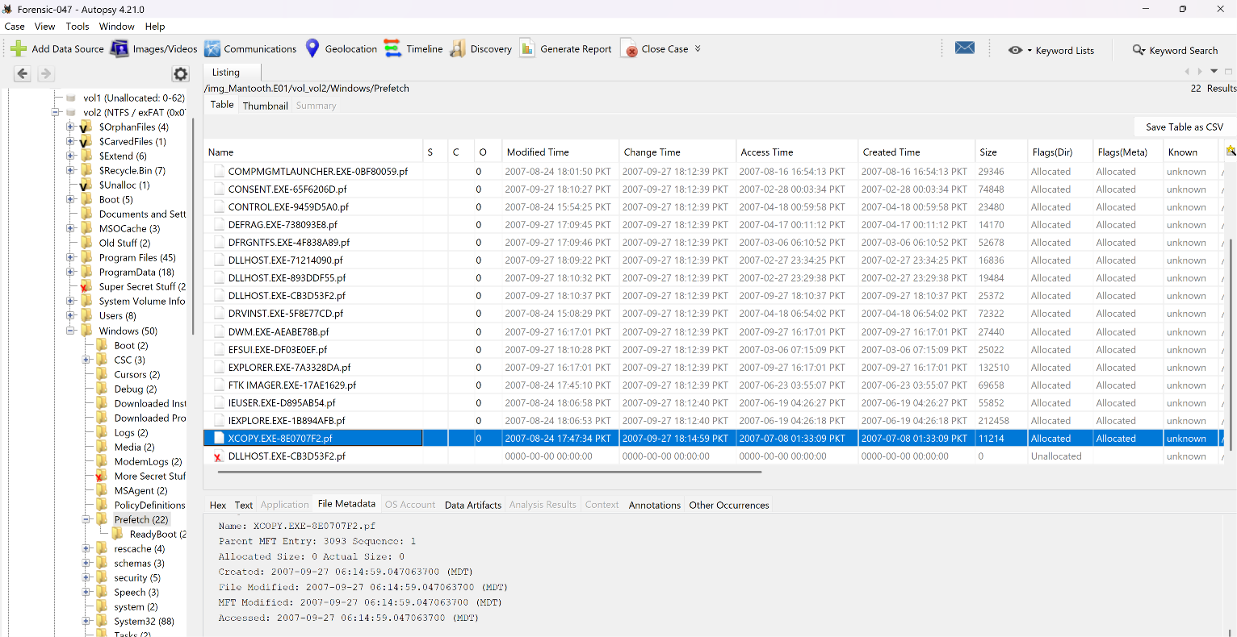
Q12. LNK files for Wes Mantooth — target path, timestamps, target still present?
Path/Tool: Recent Documents data artifact (109 entries)
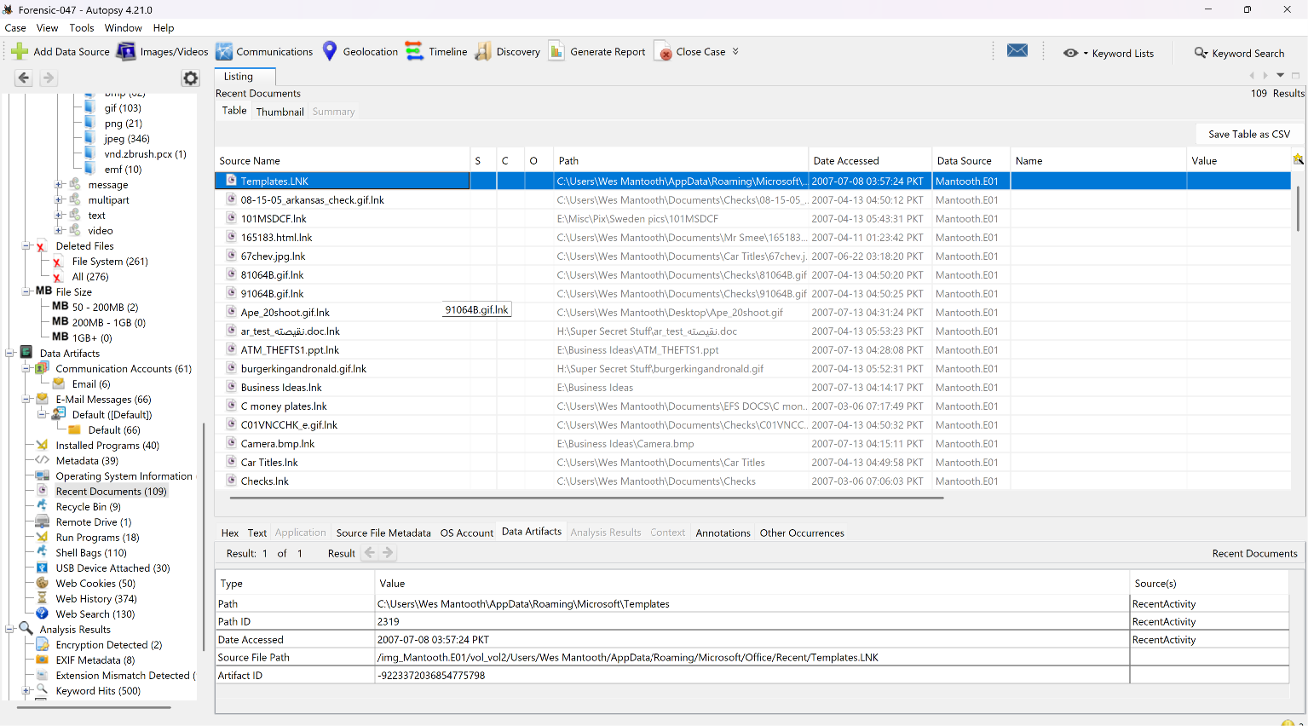
Q13. Print spooler directory — spool files, sizes, print job metadata.
Path/Tool: Windows\System32\spool\PRINTERS\ (.SPL/.SHD)
Files Found: YES
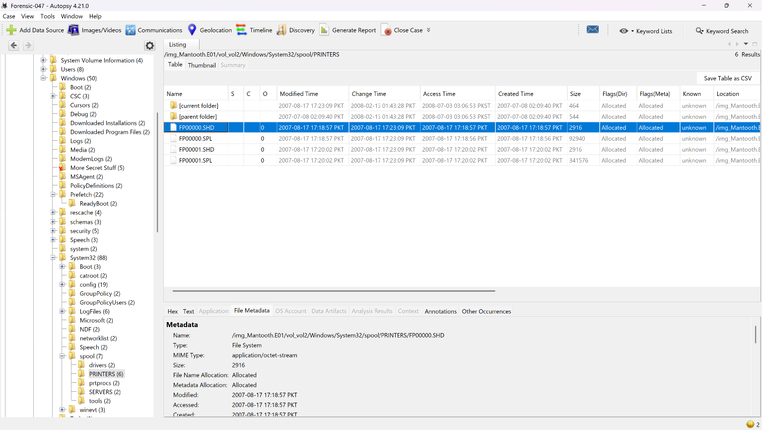
Q14. Security.evtx — logon/logoff times, event IDs, logon types, session durations for Wes Mantooth.
Path/Tool: Windows\System32\winevt\Logs\Security.evtx
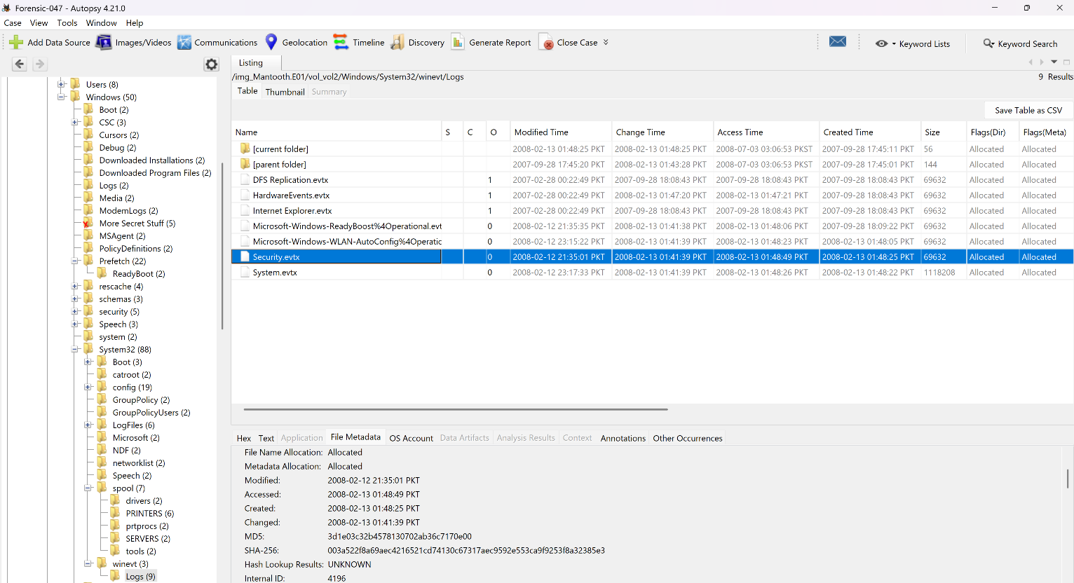
Days 70–73: Lab 2 Windows Registry Analysis
Case: Mantooth Financial Fraud Investigation | Tool: Registry Explorer / Autopsy Registry Viewer
Hives analyzed: SYSTEM, SOFTWARE, SAM, NTUSER.DAT (Wes Mantooth) — exported from Autopsy prior to parsing.

// 01 SYSTEM & NETWORK INFORMATION

What is the name of the computer?
Hive: SYSTEM
Key Path: ControlSet001\Control\ComputerName\ComputerName
Tool: Registry Explorer

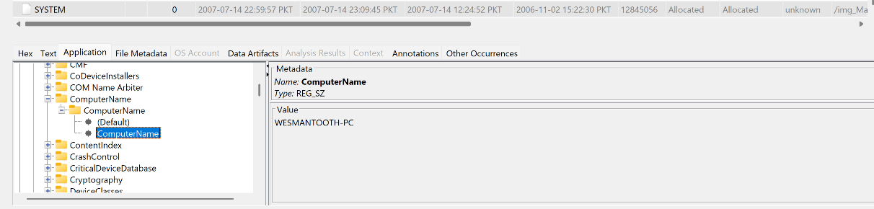
What is the time zone name as recorded in the registry? Cross-reference with Mountain Time.
Hive: SYSTEM
Key Path: ControlSet001\Control\TimeZoneInformation
Tool: Registry Explorer

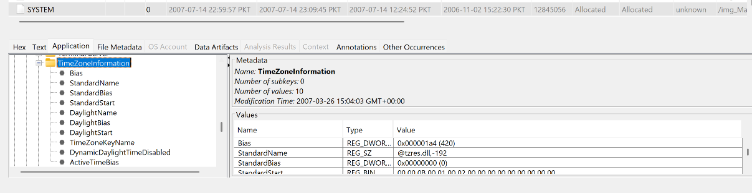

What is the IDE hard drive name as recorded in the registry?
Hive: SYSTEM
Key Path: ControlSet001\Enum\IDE\...
Tool: Registry Explorer

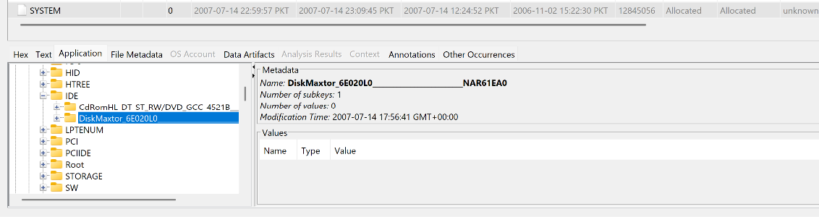

IP address of the computer, when received, and DHCP server IP.
Hive: SYSTEM
Key Path: ControlSet001\Services\Tcpip\Parameters\Interfaces\{GUID}
Tool: Registry Explorer

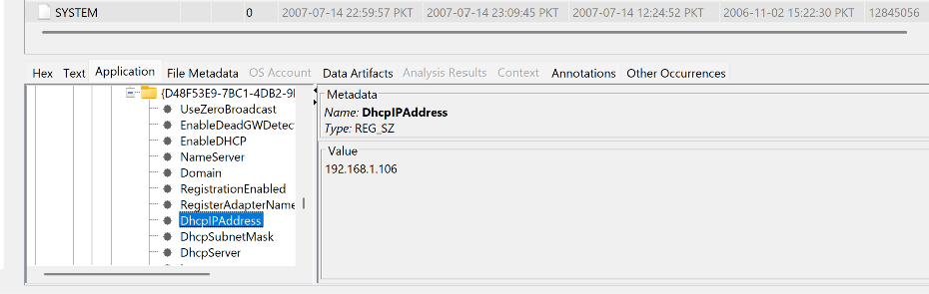

Prefetch setting (EnablePrefetcher) — value and meaning.
Hive: SYSTEM
Key Path: ControlSet001\Control\Session Manager\Memory Management\PrefetchParameter
Tool: Registry Explorer
Finding: EnablePrefetcher = 0x3 (Both application and boot prefetching enabled)

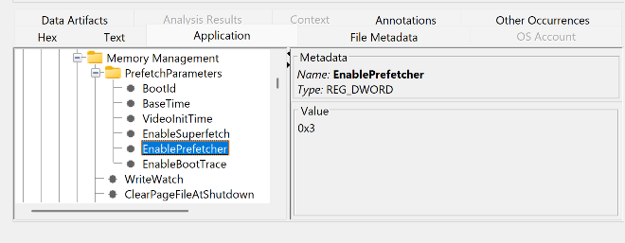

Start type for the TrueCrypt service — value and investigative meaning.
Hive: SYSTEM
Key Path: ControlSet001\Services\TrueCrypt\Start
Tool: Registry Explorer
Finding: Start = 0x1 (System loaded by the kernel at boot, alongside core system drivers)

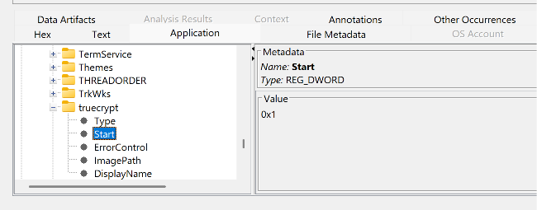

Network cards used by this system.
Hive: SYSTEM
Key Path: ControlSet001\Services\Tcpip\Parameters\Interfaces\
Tool: Registry Explorer

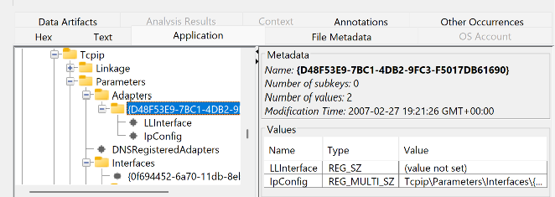

// 02 EXTERNAL DEVICES

Serial number for the Canon PowerShot SD500 digital camera — when connected. Any evidence it was also used to take photos on this machine (tie to Olympus finding, Part A Q3)?
Hive: SYSTEM
Key Path: ControlSet001\Enum\USBSTOR
Tool: Registry Explorer

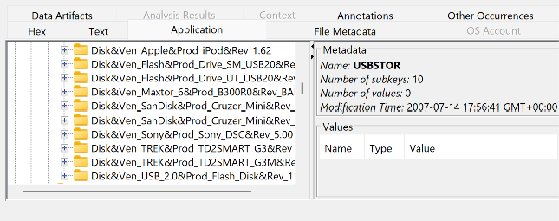

// 03 USER ACCOUNTS & PASSWORDS

User profiles created on this system.
Hive: SAM
Key Path: SAM\Domains\Account\Users\Names
Tool: Registry Explorer (SAM view)

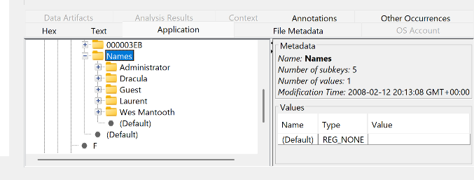

For each SAM account: username, type, created, password hint, last login, pwd last reset, pwd last failed, login count.
Hive: SAM
Key Path: SAM\Domains\Account\Users\<RID>\V
Tool: Registry Explorer (SAM view)

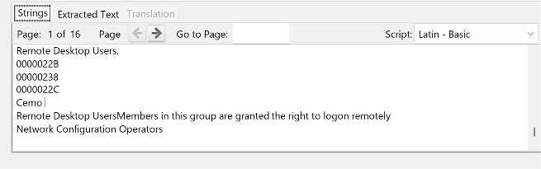

Mantooth's Yahoo Messenger username.
Hive: NTUSER.DAT
Key Path: Software\Yahoo\Pager
Tool: Registry Explorer
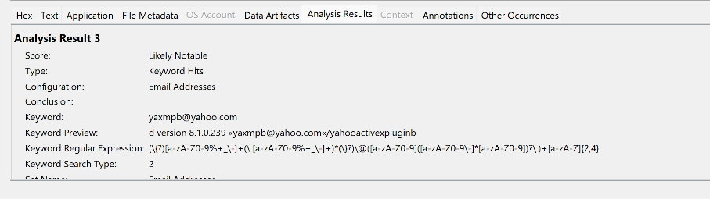
Investigation Summary — Autopsy Triage & Registry Analysis
This investigation began by establishing a defensible starting point: the disk image was verified as unaltered before any analysis took place, and its physical layout was documented. From there, triage surveyed the image for high-value evidence, surfacing a suspicious photo with camera metadata, an encrypted file, two deleted image files, a pattern of web searches, and a set of IP addresses and email accounts tied to the user. Digging deeper into Windows-specific artifacts uncovered user account activity, suspicious files in the user's profile, thumbnail evidence, a deleted program recovered from the Recycle Bin, evidence of a file-copying utility being run, shortcut files pointing to material that no longer exists on the disk, leftover print-job data, and a clear record of login/logout activity.
The investigation then moved from the file system into the registry to fill in the operational details the file-system triage couldn't fully answer. This confirmed basic facts about the machine itself — its name, network configuration, and system settings — before moving into the devices that had been connected to it, including cameras and portable storage. From there, the focus shifted to the user accounts on the system, including a stored password tied to a remote-access tool, and an online messaging identity linked to the user. The final layer of analysis reconstructed the user's actual behavior: programs installed and run, documents and images opened, files accessed from external storage, and browser activity including search history, saved pages, and typed web addresses.
Taken together, these two phases turn a set of isolated technical artifacts into a connected narrative: a machine that was actively encrypted, configured for remote access, used to stage and move files via external storage, and tied to identifiable online accounts — all pointing toward deliberate concealment and coordination around the fraudulent activity under investigation. The encrypted file, the recovered remote-access program, the printed and copied material, and the externally-staged files stand out as the central threads for further investigation.

